## ****Podcast about Pets and COVID-19 from Pets on Q****

## The Corona Virus impact on rescue groups.

[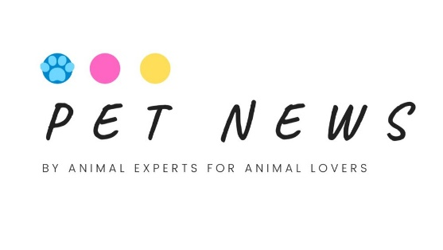](http://petsonq.com/petnews)

[**Pet News**](http://petsonq.com/petnews) **from Pets on Q (**<https://petsonq.com/>)**.**

Pets on Q is the industry leader in animal marketing, from production to booking a social media influencer. PoQ is leading the charge in changing the industry for the betterment of animals. Using temperament approved and even shelter animals in as much as we can.

[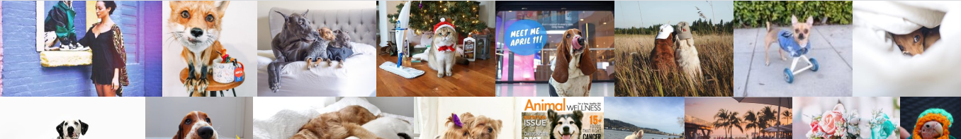](https://open.spotify.com/episode/79CVrpMWBlVxEo0QxGZ5K6?t=0)

[](https://open.spotify.com/episode/79CVrpMWBlVxEo0QxGZ5K6?t=3703)

In this episode of Pet News, we meet with two different rescue organizations and find out what is actually going on during this uncertain time around the country. How are our animals impacted by the corona virus? We meet with Christy Stevens of Hearts Alive village in Los Vegas who can shine some light on some of the good she has seen in the pet community coming together.

In a state 1,500 miles away, we speak to Natalie a small rescue in Huston, Texas Hot mess pooches. She is a breed specific rescuer who is hit hard by this already and is uncertain of her future and will share some of the challenge she is facing. How can we come together and help? Comment or message us with your opinions and who should we speak to next?

[](https://open.spotify.com/episode/79CVrpMWBlVxEo0QxGZ5K6?t=3703)

[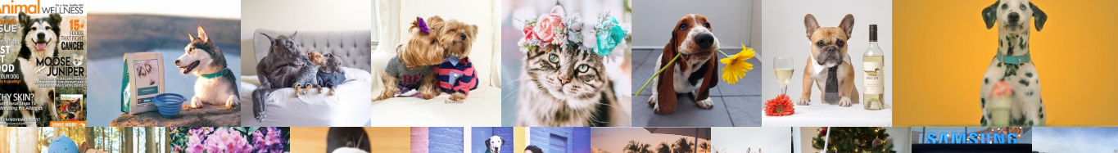](https://open.spotify.com/episode/79CVrpMWBlVxEo0QxGZ5K6?t=0)

[](https://www.instagram.com/petsonq/)[](https://www.youtube.com/channel/UCyBVBAcsah2kUlxwco1eKVA)[](https://www.facebook.com/PetsonQ/)[](https://twitter.com/petsonq)[](https://www.linkedin.com/company/pets-on-q)[](https://petsonq.com/aboutus)[](https://petsonq.com/work)[](http://petsonq.com/petnews)[](https://petsonq.com/contact-1)